Tags
command : ansible-playbook pl.yaml --tags first_task(update)
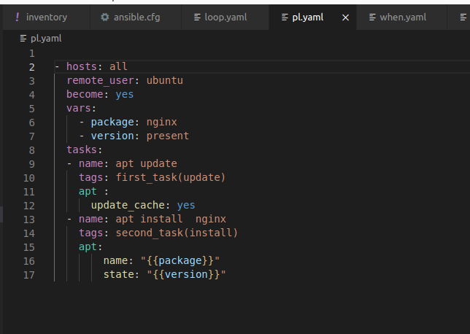
COMMAND
ansible-playbook pl.yaml --extra-vars "package=nginx version=present"

loop
1-

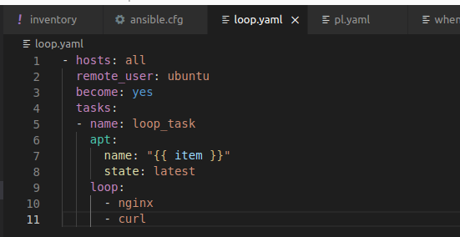

2-

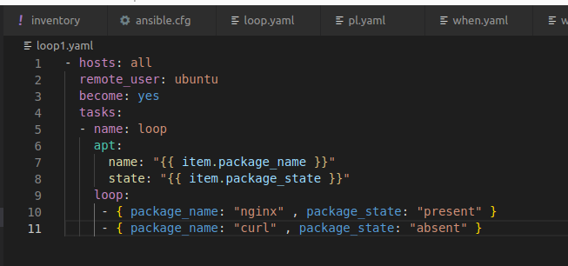

when
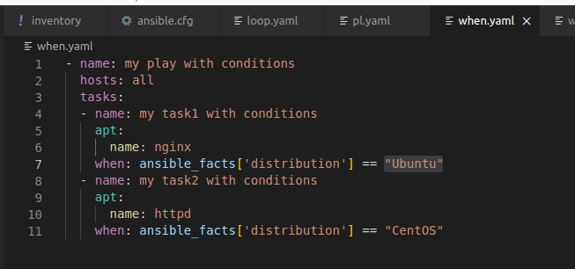
register
